(Team 7) **(Cars** **365)**

Software Design Document

Indra Shekar G (19z219) Manoj S (19z263) Sanjai M (19z241) Soumen Saha (19z245)

Mathana Sekaran T (19z264) Gowtham T (19z214)

Date: (28/09/2021)

**TABLE** **OF** **CONTENTS**

**1.** **INTRODUCTION** 2 1.1. Purpose

1.2. Scope 1.3. Overview

**2.** **UML** **DIAGRAMS** 2 2.1 Use-case Diagram

2.2 Class Diagram

2.3 Sequence Diagram 2.4 Activity Diagram

**3.** **APPENDIX** 10

**1.** **INTRODUCTION**

**1.1** **Purpose**

The purpose of this project is to create an online platform (Cars365) for buying, selling and renting used cars.

**1.2** **Scope**

The purpose of the cars365 online platform is to ease car trading and to create a convenient and easy-to-use application for car buyers and sellers. The system is based on a database with its buy, sell, rental and price prediction functions. We will have a database server supporting hundreds of major cities around India as well as hundreds of cars by various automobile manufacturers. Above all, we hope to provide a comfortable user experience along with convincing price predictions available.

**1.3** **Overview**

This design document contains UML diagrams like Class diagram, Sequence diagram, Activity diagram, Use-case diagram

**2.** **UML** **DIAGRAMS**

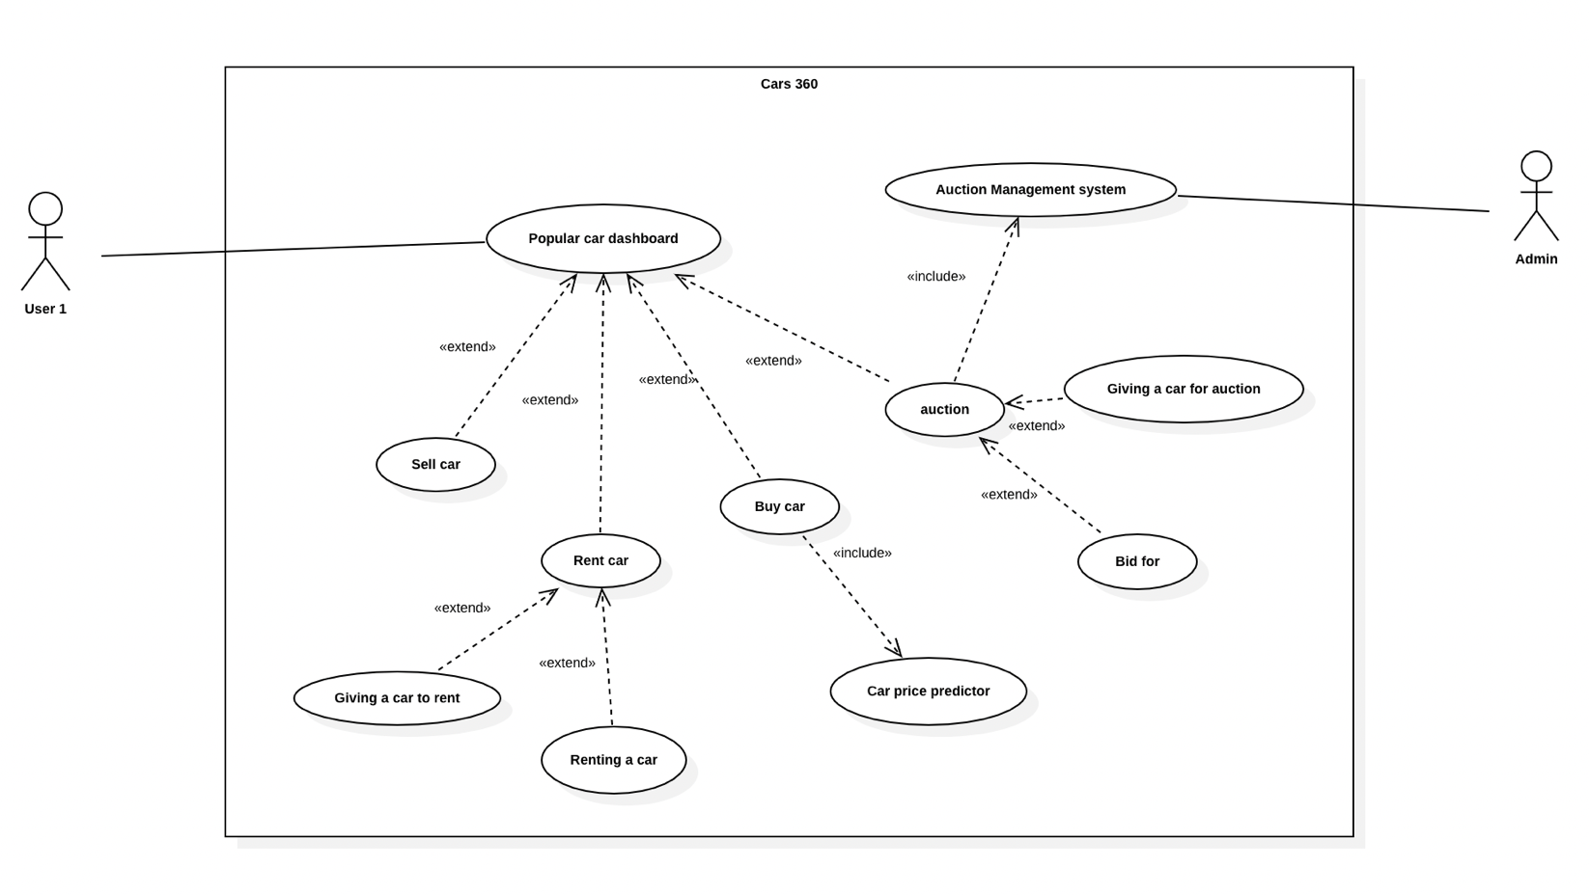**2.1** **Use-case** **diagram**

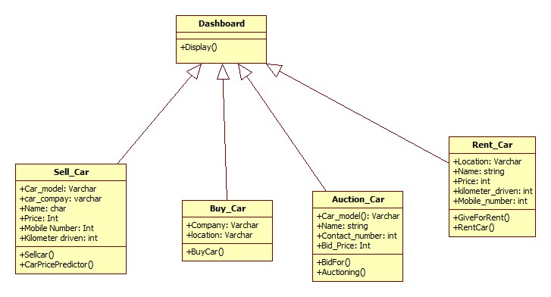**2.2.** **Class** **diagram**

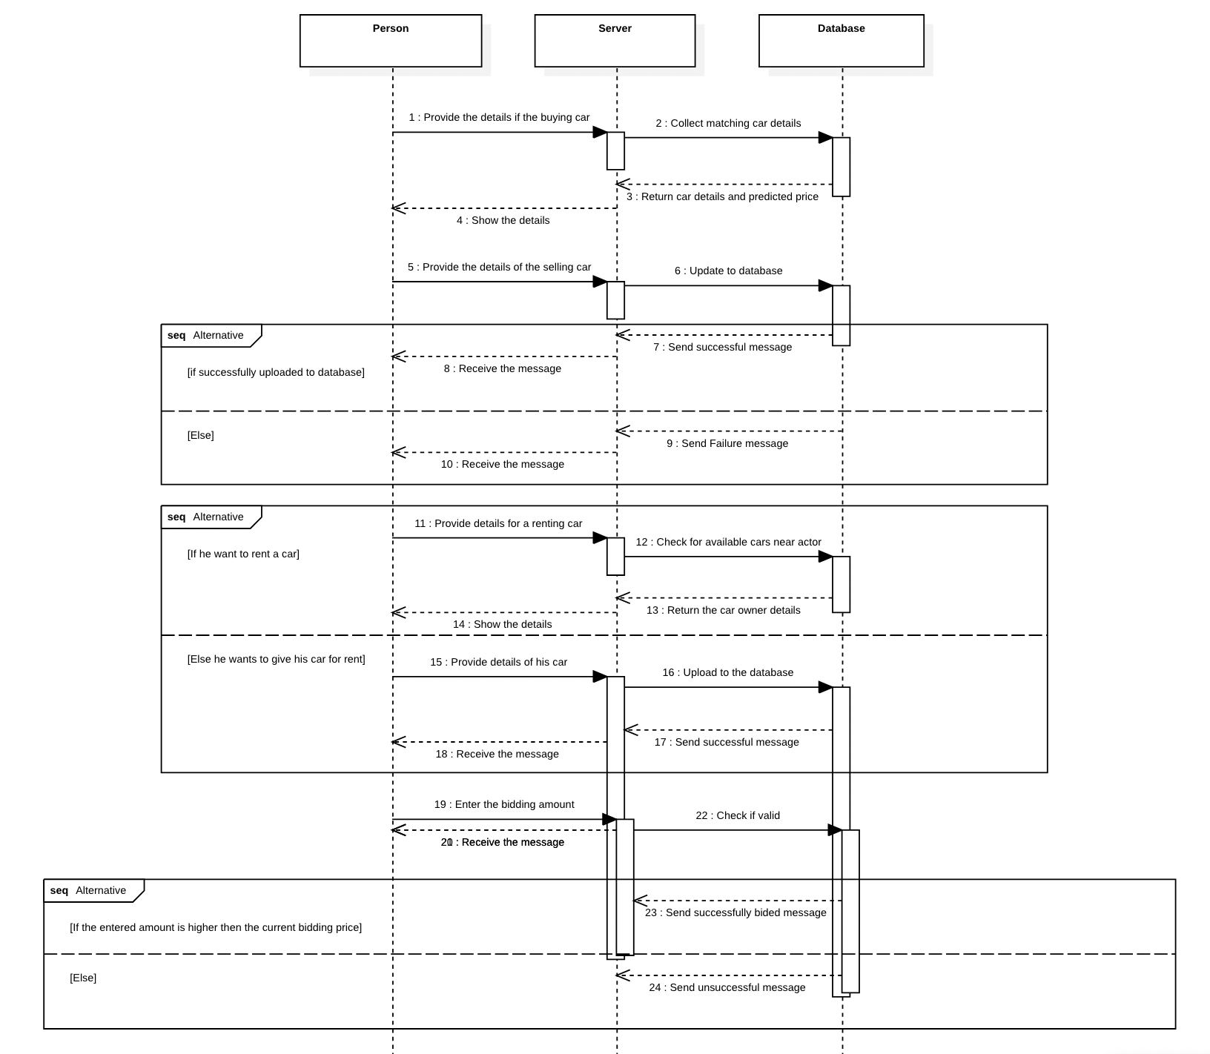**2.3.** **Sequence** **diagram**

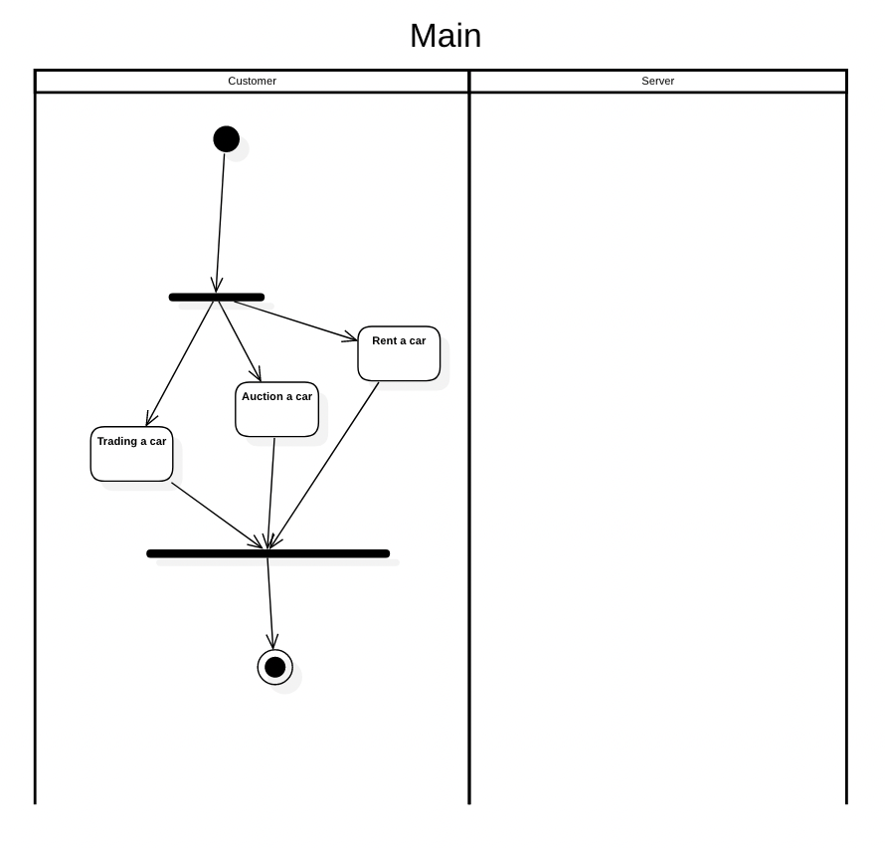**2.4.** **Activity** **diagram**

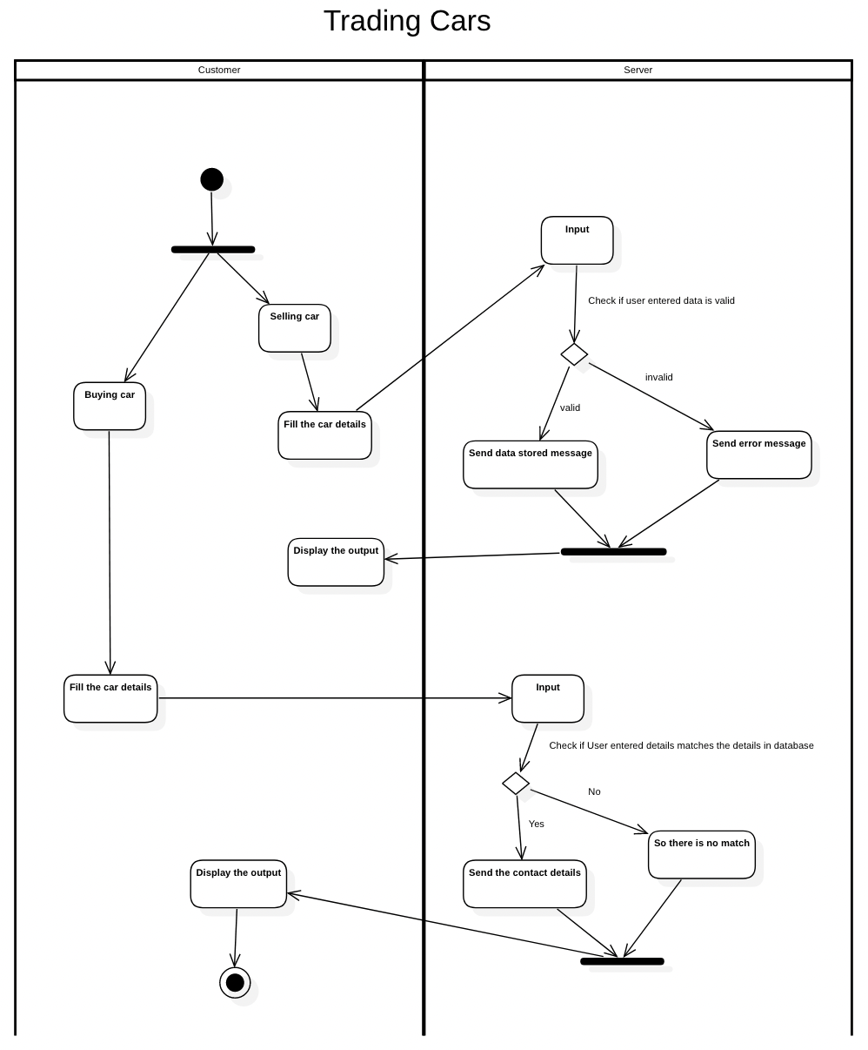

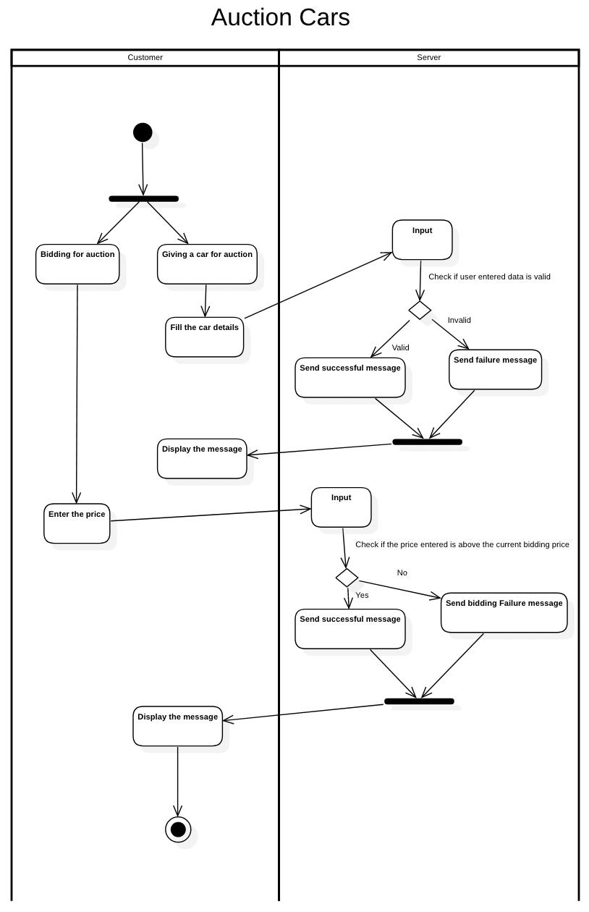

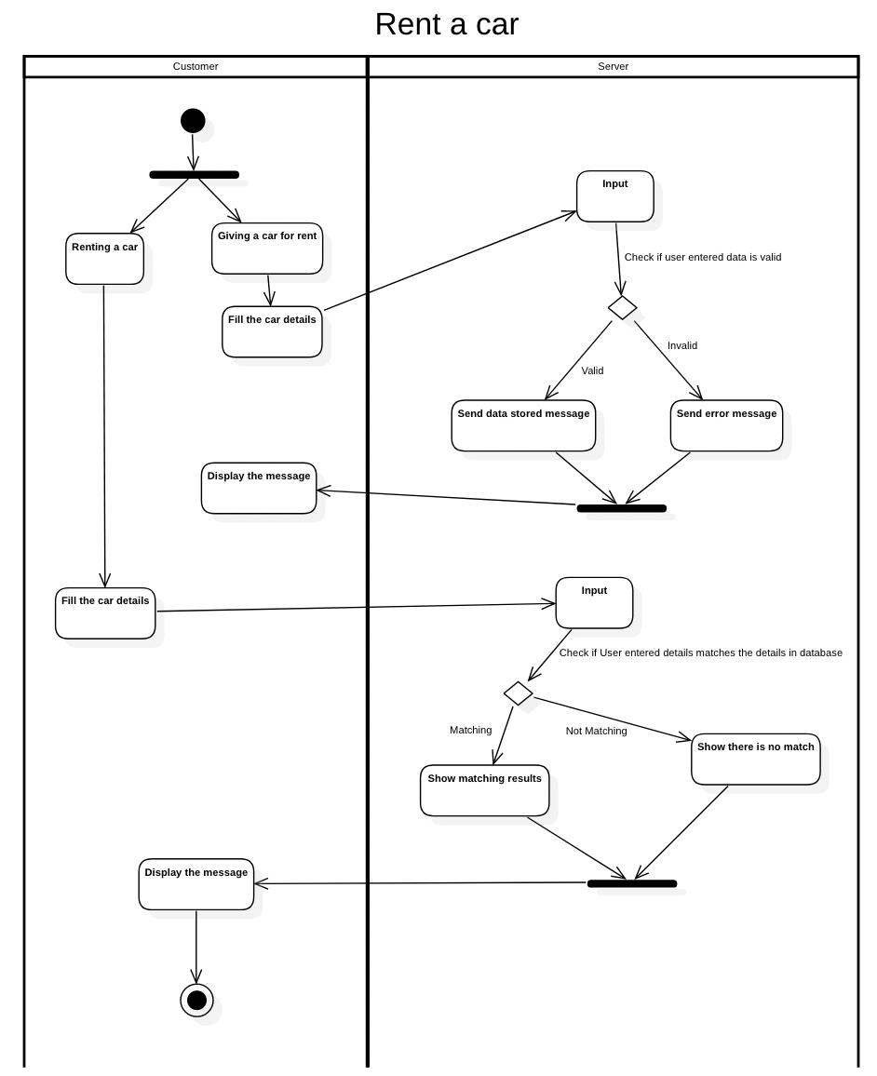

**3.** **APPENDICES**

**Appendix** **A:** **To** **be** **determined** **list**

The size of the database is to be determined based on the number of users (both buyers and sellers) and the cars data. The extension of features will be possible only after knowing the reach and responses of the active users.

**Appendix** **B:** **Analysis** **Models**

The entity-relationship model for the product functions have been shown in the above section (2.2 Product function